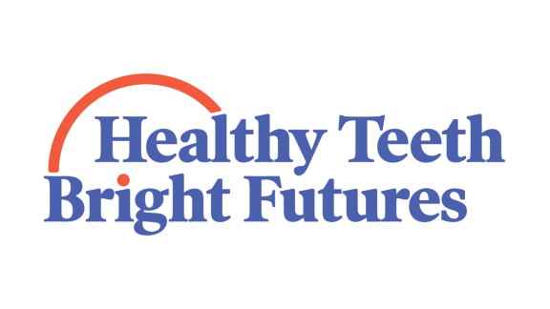
Campaign Endorsement

The Healthy Teeth Bright Futures campaign is a collaborative effort among Oregon’s oral health advocates to 1) raise awareness of the importance of oral health for overall health and educational success and 2) promote health and education system advancements to improve children’s oral health outcomes in Oregon.

The campaign builds on the work of the Oregon Children’s Dental Health Initiative that was funded by A-dec, The Collins Foundation, The Ford Family Foundation, Kaiser Permanente, Meyer Memorial Trust, Northwest Health Foundation, Oregon Community Foundation and Providence Health Systems. The Initiative funded 15 organizations across Oregon to provide comprehensive school-based dental health programs in elementary and middle schools. The programs reached schools in 22 of Oregon’s 36 counties.

The Healthy Teeth Bright Futures campaign is committed to ensuring that Oregon’s children receive access to preventive oral health services in their schools. This enables families to have an equal chance in preventing oral disease and establishing a relationship with a local dentist for long-term care. The campaign will specifically focus on improving access to preventive services for children from low income households, communities of color, and rural communities.

The Healthy Teeth Bright Futures campaign is guided by the Pediatric Oral Health Coalition, a collaborative group of representatives from Oregon’s philanthropic organizations, health system providers and insurance plans, education system, school-based dental programs, and racial justice organizations. It is currently funded and led by Oregon Community Foundation.

OCF is committed to leading an effort that is inclusive and builds consensus among oral health advocates. The Healthy Teeth Bright Futures campaign will use a variety of tools to accomplish the goals set by the Pediatric Oral Health Coalition, including convening, developing educational materials, communicating through various media, developing policy and agreements to promote health system and education system changes.

This is a new effort for OCF. It will only be successful if oral health advocates commit to partner with OCF and support the campaign. Please see the participation options on the next page.

Participation Options:

Pediatric Oral Health Coalition |  | Campaign | Legislation | Donate
- I can attend meetings and work on Coalition projects on behalf of my organization.  - I will communicate with my organization’s leadership to ensure support for activities and actions along the way.  - I can’t attend meetings on behalf of my organization, but my organization supports the effort; keep me apprised of the Coalition’s activities. |  | - My organization wants our logo on the campaign website and materials.  - My organization does not want our logo on the campaign website and materials. | - My organization endorses legislation.  - My organization does not endorse legislation. | - I can financially contribute to the effort.  - I can provide in kind contributions.
Partner | 1, 2 | 1 | 1 | 1, 2 (not required)
Sponsor | 1, 2 | 1 | 2 | 1, 2 (not required)
Friend | 3 | 2 | 2 | 1,2 (not required)

Please complete this form and send it back to Melissa Freeman at OCF as soon as you can. mfreeman@oregoncf.org

Names, titles of participants | Organization | Level of Participation
Emails |  | Notes

CEO, President or Executive Director
Name: ___________________________ email: _________________
Signature: _______________________________ Date: ___________

Thank you for your participation!
For more information, please contact Melissa Freeman, OCF Director of Strategic Projects, 503-227-6846, mfreeman@oregoncf.org or Tom Holt, tom@theholtcompany.com.

